SQL – Zoo Lab

**Part I: Zoo Lab background**

**Zoo Lab Background**

Real Pets Zoo is a not-for-profit zoo that exhibits animals that are frequently found as household pets.

The Zoo Director has decided to hire you to analyze data stored for animals at the zoo. Good analysis might reveal ways to improve the experience for zoo-goers or to improve quality of life for the animals.

"We don't even know what kind of data we're sitting on!"

The Director [me] tends to be somewhat capricious about what kind of reports she wants to see.

Pick a title for yourself that suits your position.

Good luck and good analyzing.

**Zoo Lab Prep: data model**

zoo_lab.sql

Import into your local MySQL databases.

**Zoo Lab: Data Model**

There are just 3 tables in the zoo_lab schema:

* species: describes each species that is exhibited at the Zoo
* animals: describes each animal at the Zoo
* animal_stats: tracks statistics about each animal at the Zoo

**Zoo Lab Prep: Understand the data model**

*Now we’re going to understand the structure of the tables*

List 1 row from the species table:

'1','cat','Felis catus'

List 1 row from the animals table:

* NOTE: end_date means when the animal is no longer at the zoo
* can be null when animal is still at zoo

'1','6','','2013-04-08',NULL

List 1 row from the animal_stats table:

* animals are measured every Monday
* weight (ok, mass) is given in grams

'2013-04-08','1','124'

**CHECK IN WITH THE CLASS, ARE THERE ANY QUESTIONS ABOUT THIS DATABASE?**

**Part II: Zoo Lab, extremes of the zoo animals**

**Which species has the longest scientific_name?**

scientific name is in the species table

HINT: use length() on a string column to get length of the string

'Oryctolagus cuniculus','21'

'Mustela putorius furo','21'

**Which animal has the longest individual_name? Shortest?**

Each individual animal's given name is stored in the animals table.

HINT: there can be such a thing as too short of a name.

Longest: Ms. Smallglesworth

Shortest:

'5', '', '0'

'36', '', '0'

'17', '', '0'

'34', '', '0'

'1', '', '0'

'28', '', '0'

'26', '', '0'

'12', '', '0'

'31', '', '0'

**Which animal is the most recent addition to the zoo?**

start_date is when the animal was added to the zoo.

Betty

**What species is this most recent addition to the zoo?**

**5**

**CHECK IN WITH THE CLASS, WHAT DID YOU GET FOR EACH OF THESE QUESTIONS, WHAT WAS CHALLENGING/SURPRISING?**

**Part III: Zoo Lab, summaries of the zoo animals**

**How many are there of each species?**

Your answer should report by the common_name of each species, but it may help to start with counting the number of animals per species_id.

'1','6'

'2','6'

'3','6'

'4','4'

'5','5'

'6','9'

'7','5'

**As of today, what's the average tenancy (length of stay) at the zoo?**

HINTS:

DATEDIFF(date2, date1) returns number of days of date2 - date1

IFNULL(exp1, exp2) returns exp2 if exp1 is null

CURDATE() returns the current date of the running MySQL session

**1298.8780**

**Using the animal stats table, tell me the average weight for each individual animal, across all of that animal's weigh-ins**

The zoo director is not exactly sure what this would reveal, but wants you to go for it. She adds, "oh, and I'm not that great with the metric system. Can you report weight in pounds?"

Measured weights are in animal_stats table.

HINT:

ROUND(x, d)

-- rounds the number **x** to the nearest **d** decimal points

floor(x)

-- rounds DOWN to the nearest integer

%

-- modulo, returns remainder

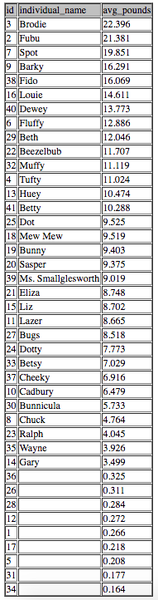

**OPTIONAL CHALLENGE:**

report weights in pounds and ounces!

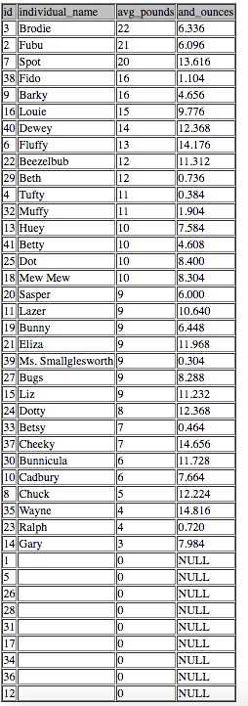

**The zoo director says to you, "you know what, maybe grams is better. Let's use metric from here on!" "Grams is fine, but I still want species identified by common names."**

**What's the average measured weight per species?**

Define average weight per species as average of each animal's average (from last question)

'1','4887.0537'

'2','8578.9569'

'3','3409.2977'

'4','1876.8120'

'5','4215.5673'

'6','116.3435'

'7','5297.5422'

**CHECK IN WITH THE CLASS, WHAT DID YOU GET FOR EACH OF THESE QUESTIONS, WHAT WAS CHALLENGING/SURPRISING?**

**Part IV: Zoo Lab, zoo animals with seniority**

**Which animals have been here since December 01, 2014 or earlier?**

HINT: "been here" implies still here

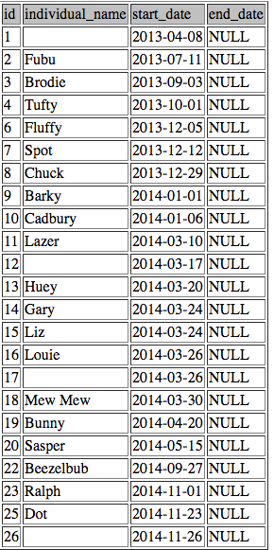

**Of the animals who have been here since 11-23-2015, which grew the most, by percentage weight, between 12-01-2014 and 11-23-2015, a period where we implemented a new feeding schedule.**

HINTS:

* use the ids from the last query
* assume no gaps in data
* use hardcoded earliest and latest dates

Need animals who exist from 12/01/14 - 11/23/15

divide weight of 11/23 by 12/01

**CHECK IN WITH THE CLASS, WHAT DID YOU GET FOR EACH OF THESE QUESTIONS, WHAT WAS CHALLENGING/SURPRISING?**

**Part V: Zoo Lab, Barky vs. Dot**

**How do Barky and Dots weights compare in their first year at the zoo?**

The director wants to see their weights for their first year at the zoo,

even though they started at the zoo at different times.

HINTS:

* Ranking query!
* Return the following columns – week number (1-52), Barky weight, Dot weight

Recall from Acrobatiq:

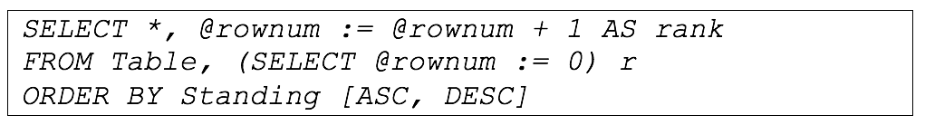

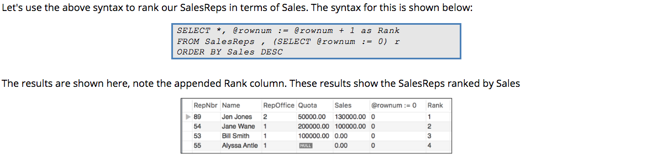

First just consider Barky, then do the final table.

**CHECK IN WITH THE CLASS, WHAT DID YOU GET FOR THIS QUESTION, WHAT WAS CHALLENGING/SURPRISING?**

**Part VI: Zoo Lab, sneaky zoo animals**

**Did any animal not get weighed right away?**

animals table lists a start_date

animal_stats gives cal_dates of weighings, always on Mondays

Did any animal not get weighed the first Monday after they were added to the zoo?

HINT: use MIN() to find earlier start_date per animal

'30','Bunnicula','2015-05-29','31'

**That sneaky Bunnicula!**

**Ok, the zookeepers have found weighing records for Bunnicula’s first weeks at the zoo:**

Construct a SQL INSERT query that inserts these missing rows to the animal stats table.

animal id = 30

6/1/15 2.4kg

6/8/15 2.38kg

6/15/15 2390

6/22/15 2401

yyyy-mm-dd == 23

**CHECK IN WITH THE CLASS, WHAT DID YOU GET FOR EACH OF THESE QUESTIONS, WHAT WAS CHALLENGING/SURPRISING?**

**Part VII: Zoo Lab, challenge questions**

**OPTIONAL CHALLENGE: Of the animals no longer at zoo, did any have an unusual weight pattern?**

Can we look at the animals that aren't at the zoo, who may have died, to see if they had unusual weight patterns?

Let's look at the last 8 weeks of weigh-ins.

Graphing might help visualize weight trends

HINTS:

* remember that animals who've left the zoo have an end_date
* yup, ranking query again

**OPTIONAL CHALLENGE: Do any species have seasonal weight patterns?**

The director wants to know if you can spot seasonal weight patterns in any species.

Graph the weights of individuals, grouped by species.

Conclude on which species do or don't have seasonality.